Chapter 10, Problem 72.

Compute i_{o}(t) in the op amp circuit in Fig. 10.115 if v_{s} = 4 cos(10⁴t) V.

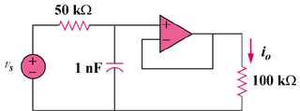

Figure 10.115
For Prob. 10.72.

